Biocultural Heritage Landscape to be established by indigenous peoples of the Eastern Himalayas

November 24, 2017

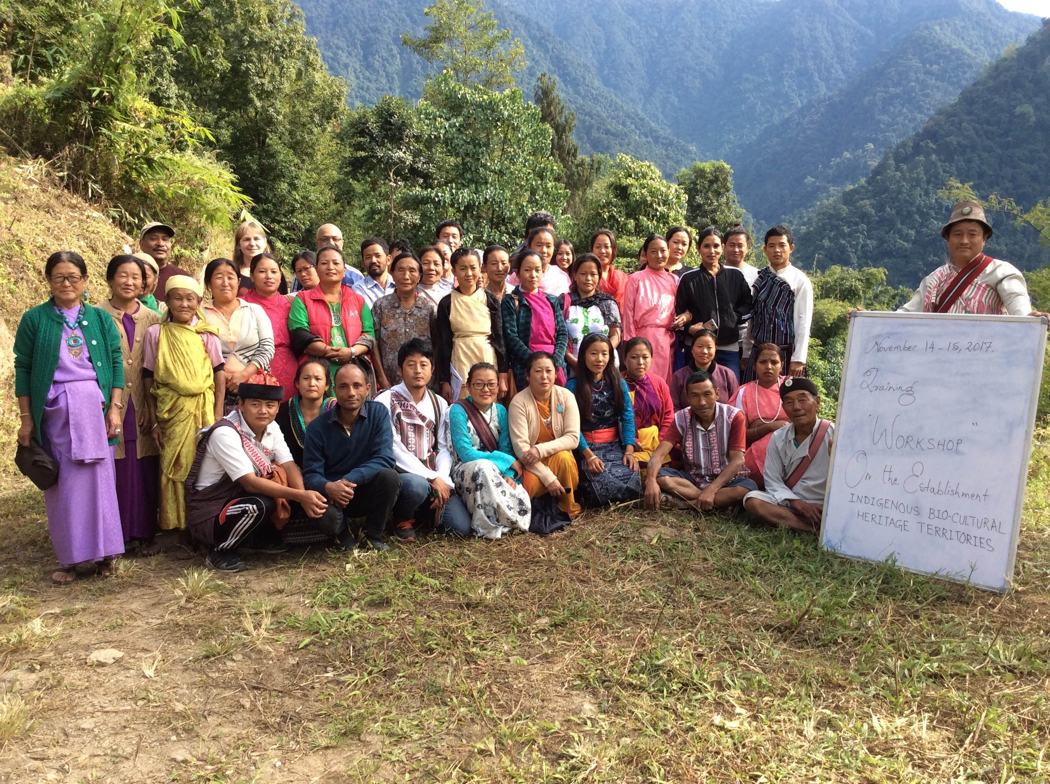

From November 13 to 17, 2017, fifty members of seven indigenous ethnic groups near Kalimpong, Eastern Himalayas, India, participated in a training workshop on Methods, Tools and Processes for Establishing Biocultural Heritage Landscapes. The workshop was organized by the Centre for Mountain Dynamics (India) and the International Network for Mountain Indigenous Peoples (INMIP), with support from Asociación ANDES (Peru).

As a result of the workshop, the participants committed to establish a Biocultural Heritage Landscape with a focus on the protection of the biocultural heritage of indigenous peoples of the Eastern Himalayas, including Lepcha and Limbu communities. The area, which is adjacent to a National Park, is among the richest in the world for diversity of food crops, wild plants and culture. Based on the rich diversity and cultural significance of orchids, the participants decided to use the orchid as an emblematic species, under which economic development, conservation, and good governance of natural resources will be carried out.

The workshop participants agreed to work together to develop a work plan for economic development, conservation, the protection of cultural and spiritual values, and the development of an appropriate policy and legal framework under Indian and international law to enhance local food security and the conservation of biodiversity in times of climate change.
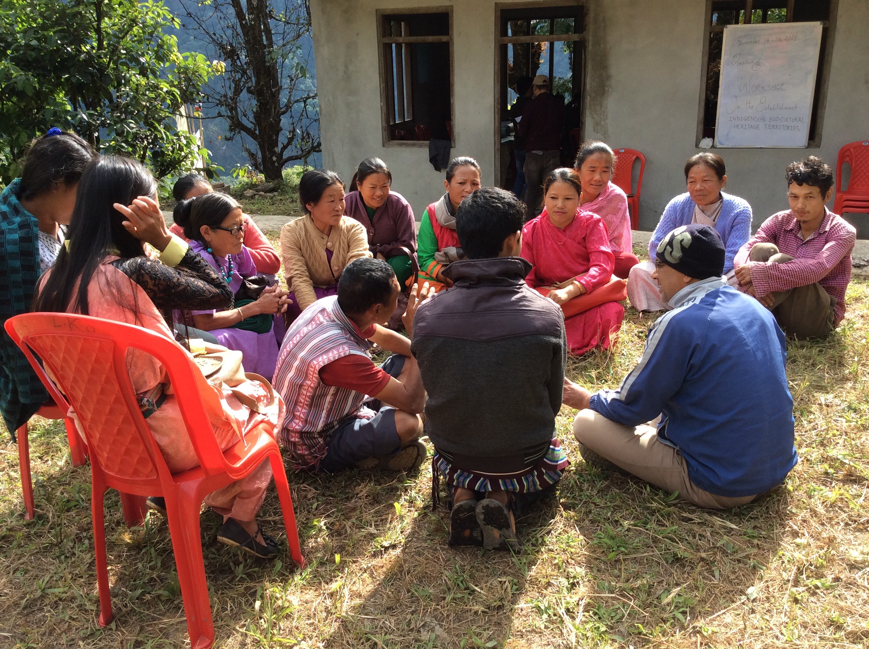

INMIP, a member of Mountain Partnership of the FAO, has been working closely with the Centre for Mountain Dynamics, Asociacion ANDES, and the International Institute for Environment and Development (IIED) within an international exchange program. Under this program, members of the Lepcha community of the Eastern Himalayas visited Quechua communities of the Potato Park in an exchange hosted by Asociacion ANDES in Cusco, Peru in April 2017.

The event was organized with support from INMIP, which is funded by The Christensen Fund, Tamalpais, Newfield Foundation and UNDP, Asociacion ANDES, with funding from the Swift Foundation, and IIED’s SIFOR project (Smallholder Innovation for Resilience), which is funded by the European Union.

Contact information:
Centre for Mountain Dynamics
Yusuf Simick
simick515@gmail.com
(+91 3552) 259 266

International Network of Mountain Indigenous Peoples (INMIP)
Alejandro Argumedo
alejandro@andes.org.pe
(+51 84) 245 021
(+51) 984 706 610

